Project Design Phase-II
Solution Requirements (Functional & Non-functional)

Date | 30 September 2026
Team ID | SWTID-2026-6284
Project Name | AI WEATHER WISE
Maximum Marks | 4 Marks

- Functional Requirement
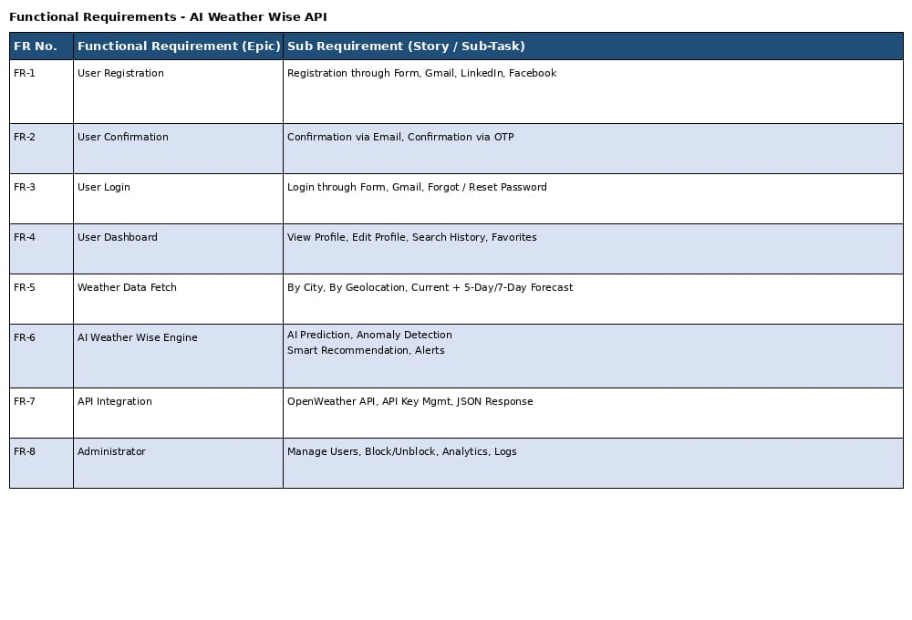

- Non-functional Requirements:

